Hypochlorous acid in the human body.

The human body produces a highly effective antimicrobial solution called hypochlorous acid to fight infection. White blood cells release this natural oxidant to fight invading pathogens. The hypochlorous acid produced by the human body’s immune system:
- Reacts readily with a variety of microbial sub-cellular compounds
- Interferes with their metabolic processes
- Kills individual bacterium exposed within milliseconds
When an invading pathogen or infection threatens a human cell, the body's immune system responds by destroying the pathogen before it can harm the cell. The invading pathogens are engulfed by white blood cells called neutrophils by the process of phagocytosis. This antimicrobial process is called the Oxidative Burst Pathway.

The Human Response
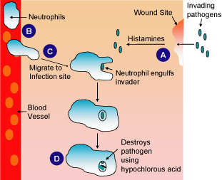
- When a wound breaks human skin, it creates a gateway for harmful pathogens to invade human cells.
- Neutrophils, which are a type of white blood cell, live in human blood vessels.
- When pathogens invade a human cell, neutrophils travel to the infection site to destroy the invading pathogen. The first step in this process is engulfing the pathogen.
- Once the neutrophil has completely surrounded the pathogen, it produces an oxidant, hypochlorous acid. Hypochlorous acid is a biocide, meaning it kills organic material. Once produced by the neutrophil, it kills the bacteria almost instantly.

