Příloha | 4.1 Vstupní kompetenční dotazník
Tematický blok | 2.1 Tematický blok č. 1 (Móda)
Téma | 2.1.1 Téma (Móda a historie)

Vstupní kompetenční dotazník
Trochu jiná angličtina 2
Na začátek tě poprosíme o vyplnění krátkého dotazníku. Nejedná se o školní test, který by hodnotil tvé znalosti a z kterého bys dostal/a známku. Žádná odpověď není ani dobrá ani špatná. Cílem dotazníku je zjistit, jaké jsou tvoje zkušenosti a názory.
Otázky pro vstupní dotazník:
- V angličtině vyjmenuj 5 různých termínů spojených s tématem módy a 5 druhů adrenalinových sportů.
Móda: Sport:
______________________ _______________________
______________________ _______________________
______________________ _______________________
______________________ _______________________
______________________ _______________________

- Daří se ti využívat angličtiny v konverzaci o jednotlivých tématech či prezentacích?
- ano
- ne

- Daří se ti analyzovat a srovnávat klíčové informace v předložených textech?
- ano
- ne

- Daří se ti vyhledávat informace na internetu z různých zdrojů a vytvořit na počítači zábavné úkoly pro tvé spolužáky?
- ano
- ne

- Daří se ti respektovat spolužáky, hledat řešení při práci ve skupině a přistupovat k ní zodpovědně?
- ano
- ne
Příloha | 4.2 Přísloví
Tematický blok | 2.1 Tematický blok č. 1 (Móda)
Téma | 2.1.1 Téma (Oblečení a historie)
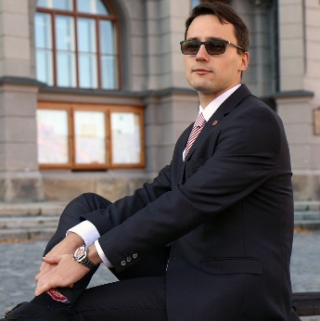
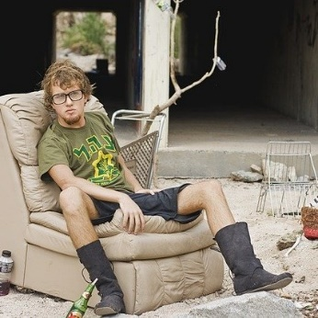

A tailor makes a man! Šaty dělají člověka!

A tailor makes a man! Šaty dělají člověka!
Příloha | 4.3 Alfa box
Tematický blok | 2.1 Tematický blok č. 1 (Móda)
Téma | 2.1.1 Téma č. 1 (Oblečení a historie)
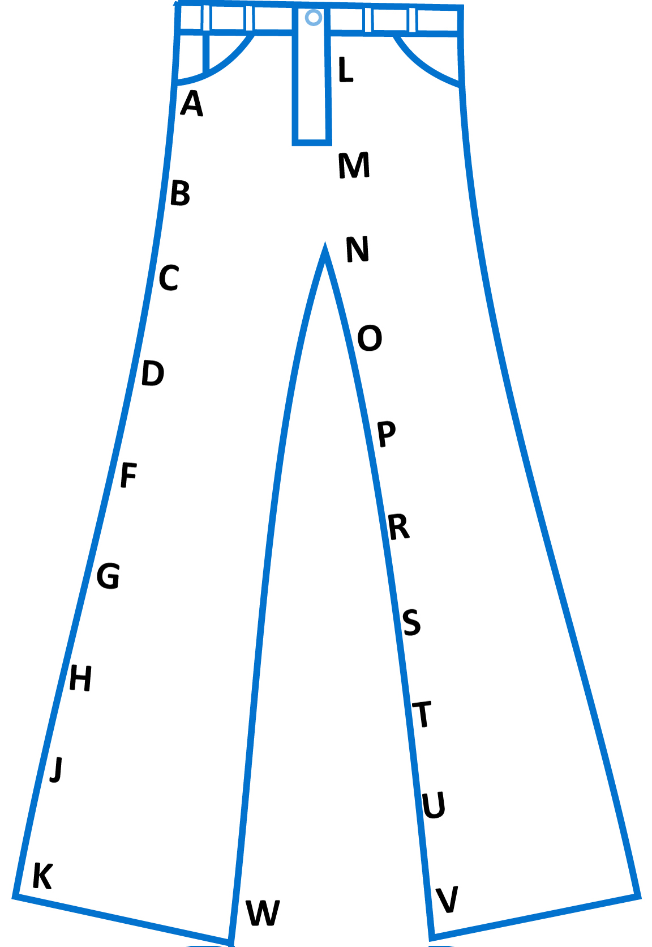

Příloha | 4.4 History of clothing
Tematický blok | 2.1 Tematický blok č. 1 (Móda)
Téma | 2.1.1 Téma č. 1 (Oblečení a historie)

History of clothing
Do you sometimes stand in front of your wardrobe and think what to wear? Have you ever thought for, let’s say, twenty minutes or more? You are not alone. People have been thinking about this theme for thousands of years.
People have always worn clothes. They started to wear animal skin – leather and fur, they made clothes from grasses and leaves too. Mostly, clothes were worn for warmth and cover from the hot sun. It lasted a long time to make these clothes. People wore them, but they did not clean them very often.
People often wear clothes to be identified with a certain group. It started long ago. Every tribe (kmen) had its own style. Clothes help you identify the same groups of people or you can recognize where they are from. People invented a loom 9,000 years ago. They used different kinds of fibre, so finally people wore mostly linen, silk and cotton clothes.
Greeks and the Romans wore fabric which was unsewn (nesešitá). The fabric was expensive and they did not want to cut it. The toga was worn by free Roman men. Men and women wore chiton which was short to knees for men and longer for women.
Until the 12th and 13th century, clothing looked simple. By the beginning of the 14th century, men and women started to wear a different style of clothing: it was a big change from the tunics. Fashion began in Europe in the 14th century. Wool was the most popular fabric for all people in Renaissance Europe. This is a very important period in the fashion history, because of the high interest in fashion among the aristocrats.
In the 18th century a sewing machine was invented and later, during the Industrial Revolution, the power loom. Fabric had better quality, was made faster and was cheaper.
The first fashion designer of the world was born in the 19th century. His name is Charles Frederick Worth. It was also a kind of revolution in the fashion scene. A lot of new parts of clothing were invented just in the 19th century (jeans, the baseball cap, bra etc.).
The 20th century invented synthetic fibres, which are cheaper than natural fibres. A lot of fashion styles started in the 20th century. Fashion began to change faster and faster we can say that since the Second World War fashion has been changing every year. Every designer has his own style and people love their individuality.
What was revolutionary? Do you use buttons, Velcro or zips? The last two are very young. People had buttons as early as in 2000 BC, but functional buttons appeared first in Germany in the 13th century. During the 14th century, buttons became a big business. In 1948, a man named George de Mestral was walking his dog in the Alps in Switzerland. He saw that burrs (ostnaté plody) were stuck (uchycený) to his dog's fur. They were stuck to his socks, trousers and jacket too. Under the microscope he saw they had tiny hooks and that inspired him. In 1955 he patented Velcro. A lot of men thought about zips even in the 19th century. The first zips were used for closing boots and tobacco bags.
Již ve starověku se lišilo odívání dle vrstev obyvatelstva. Oblečení tak přispívalo k odlišení jednotlivých profesí a postavení člověka ve společnosti. Po celou dobu odrážela móda stav ve společnosti, se změnami postavení žen ve společnosti docházelo k vývoji ženského odívání. Dříve se záležitosti módy týkaly především vyšších, bohatších vrstev. Ještě v 19. století byly oděvy rodinným majetkem, pečovalo se o ně a dědily se. Až průmyslová revoluce přinesla změny a oděv se stal spotřebním zbožím.
Příloha | 4.5 Myšlenková mapa
Tematický blok | 2.1 Tematický blok č. 1 (Móda)
Téma | 2.1.1 Téma č. 1 (Oblečení a historie)

HISTORY OF CLOTHING
inventions
materials
společnost

Příloha | 4.6 Sebehodnocení
Tematický blok | 2.1 Tematický blok č. 1 (Móda)
Téma | 2.1.1 Téma (Oblečení a historie)
1. blok: Móda
Umím nejméně 7 nových slovíček a dokážu je použít.
Jsem schopen/schopna anglicky sdělit nejméně pět vět týkajících se historie oblékání.
Rozumím tomu, co mi spolužák anglicky říká.
Spolupracuji se spolužákem tak, abychom splnili zadání.
Dokážu pracovat s grafickým organizérem a efektivně ho využívat pro záznam a sdílení informací.

2. blok: Módní návrháři
Dokážu napsat anglicky několik otázek, které bych položil/a módnímu návrháři.
Rozumím tomu, co říká spolužák, a odpovídám a reaguji na otázky a informace.
Dokážu anglicky uvést, jaké dovednosti by měl módní návrhář mít (minimálně 5) a co ke své profesi potřebuje.
Během práce ve dvojici podporuji spolupráci, dokážu poradit, podpořit spolužáka.
Rozumím textu v angličtině tak, že jsem schopen/schopna sdělit klíčové informace v českém nebo v anglickém jazyce.

3. blok: Obchody s módou
Dokážu odpovídat na kladené otázky, reagovat na ně v rozvitých větách.
Orientuji se v textu, shrnu různými způsoby přečtený text.
Jsem schopný/á vidět pozitivní i negativní stránky módy a umím je popsat.
V průběhu práce ve skupině dodržuji pravidla a sleduji průběžné instrukce.
Jsem schopen podat nejméně osm informací v angličtině o obchodech a práci dětí v továrnách.
Příloha | 4.6 Sebehodnocení
Tematický blok | 2.1 Tematický blok č. 1 (Móda)
Téma | 2.1.1 Téma (Oblečení a historie)
Při práci ve dvojici, trojici jsme hledali řešení, spolupracovali.
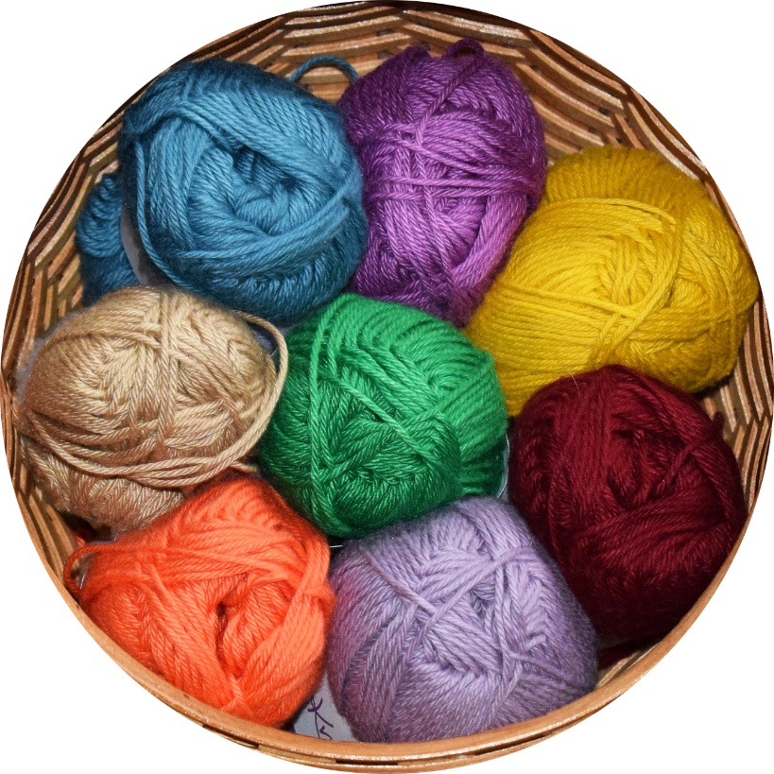
Nejvíc jsme se naučil/a…
Práce ve dvou či ve skupině mi vyhovovala.
Používal/a jsem angličtinu co nejvíce dle svých schopností.
Na počítači jsem vytvořil/a zábavný úkol.
K práci jsem přistupoval/a zodpovědně, snažil/a jsem se co nejvíce zapojit.
Chtěl/a bych si zopakovat…
Příloha | 4.7 Módní návrhy
Tematický blok | 2.2 Tematický blok č. 2 (Módní návrháři)
Téma | 2.2.1 Téma (Návrháři a dovednosti)
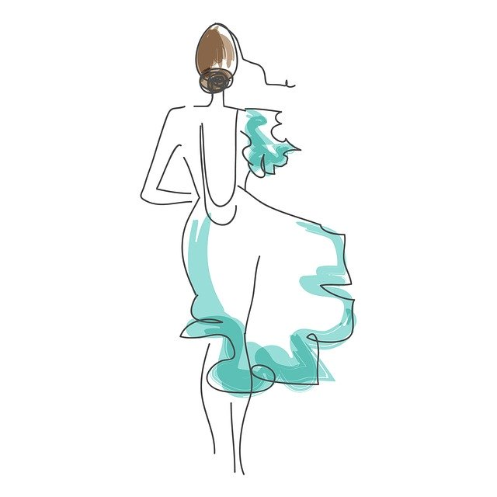
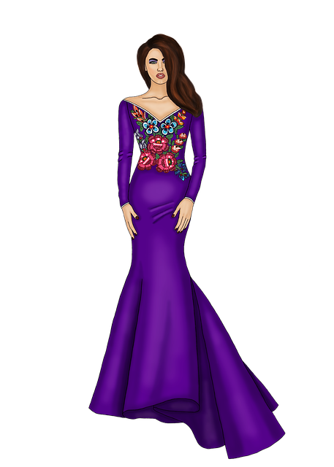

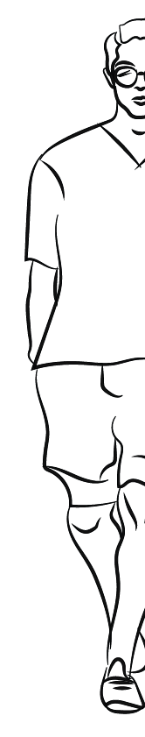

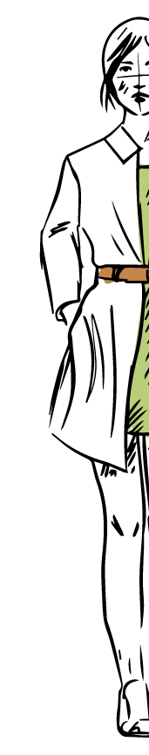
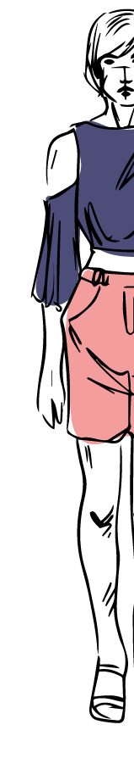
Příloha | 4.8 Slovní zásoba
Tematický blok | 2.2 Tematický blok č. 2 (Módní návrháři)
Téma | 2.2.1 Téma (Návrháři a dovednosti)

Match the words and pictures
DOVEDNOST
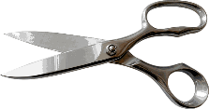
skill
share
NAVRHNOUT
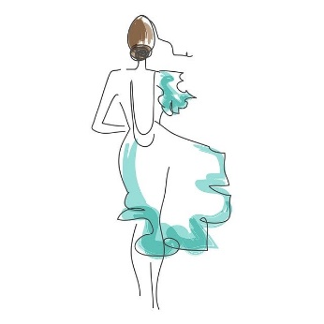
artistic
creative
KREATIVNÍ
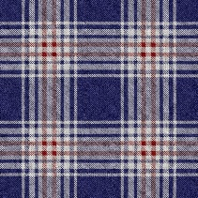
customer
sketch
UMĚLECKY NADANÝ/Á
pattern
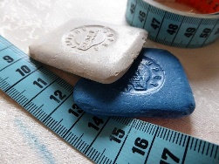
design
SDÍLET
scissors
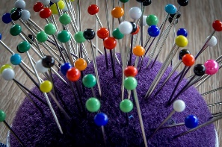
dummy
tape measure
ZÁKAZNÍK
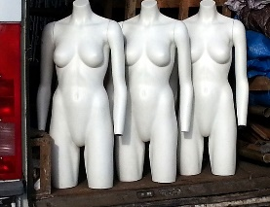
tailor´s chalk
pins

Příloha | 4.9 Questionnaire
Tematický blok | 2.2 Tematický blok č. 2 (Módní návrháři)
Téma | 2.2.1 Téma (Návrháři a dovednosti)

Questionnaire
STATEMENTS  You / He / She … | YOU | FASHION DESIGNER
 |  | What you think | After reading
Be excellent at communication
Be creative
Can sketch
Use more than two languages
Use a computer
Be good at playing PC games
Have strong drawing skills
Can make websites
Use a sewing machine
Understand fabric, patterns, colours
Can repair all things
Can measure, sew
Practise sport, staying fit
Have good presentation skills
Be a good driver
Have good eyes for details
Be late
Not open to feedback
Understand business

Příloha | 4.10 Text
Tematický blok | 2.2 Tematický blok č. 2 (Módní návrháři)
Téma | 2.2.1 Téma (Návrháři a dovednosti)

Fashion designers
Fashion design is the art and profession of designing clothes. Fashion designers create clothes that people wear and clothes that are attractive. They use a lot of materials to work with and they also use many colours and patterns. Most clothing is designed for every-day wear.

Charles Frederick Worth was the first designer who sewed his label into the clothes he made. It happened in the 19th century. He was a shop assistant and in 1845 he moved to Paris, where his wife was a model. He started to make dresses for his wife and his customers liked her dresses as well. He worked with luxury fabrics and he advised his customers what to wear.

After that, many design houses began to have artists who sketched designs. These pictures were shown to customers and if they liked it, the dressmaker or tailor (švadlena/krejčí) started to sew it. Until the 1950s, all clothing was made for a specific client. It had a high quality, was made from expensive fabric and was made with a great attention to detail.

Some people prefer to buy ready-to-wear clothes by their favourite fashion designer. They are not made for individual customers, but they are made in small quantities, which makes them exclusive – and also expensive. Fashion houses present ready-to-wear collections every season during an event called Fashion Week. They are made in standard sizes, so they fit most people.

Most people buy their clothes at mass market (hromadný trh). Fashion industry waits to make sure a certain style of new clothes is popular and then produce their own versions of the original look. Cheaper fabrics and easier techniques for sewing are used and clothes are sold cheaply.

Popular designers make a lot of money. Maybe you know some of them because they have one name or a nickname to identify themselves. Kelvin Klein started designing suits and coats for men in 1968. Giorgio Armani and Miuccia Prada are the richest fashion designers. Blanka Matragi is a world-famous Czech fashion designer.

To become a great fashion designer, you need certain skills. You must be creative and artistic. Strong drawing skills are necessary for you to put your imagination on paper. You can improve this skill and take special classes to practise sketching different clothes. Super designers must have a brilliant eye for details. Strong visualization is important for designers. Computers are popular nowadays and if you like them, it is great too because you can use special programmes there.

You will also need to sew, measure and pin fabrics on a dummy. It may surprise you that fashion designers do not work alone – they share their ideas with colleagues, so they need excellent communication and interpersonal skills. To survive in a fashion world, they must understand business – money, sales and marketing. Creativity is important, but when you do not understand business, you go bankrupt.

Příloha | 4.11 Questions
Tematický blok | 2.2 Tematický blok č. 2 (Módní návrháři)
Téma | 2.2.1 Téma (Návrháři a dovednosti)

Příloha | 4.12 Ask and react
Tematický blok | 2.3 Tematický blok č. 3 (Móda kolem nás)
Téma | 2.3.1 Téma (Obchodní domy)
What is fashion for you? | What is your favourite clothes shop? Do you like going shopping? | Where do you buy  clothes?
What style do you  prefer? | What clothes don´t you like and why? | What are some of your favourite clothing brands?
Which are your favourite clothes? | Which colours do you prefer? | Who do you go shopping with?
Do you know  any famous  fashion designers? | What skills do you need to be a fashion designer? Name at least 5 of them. | Who was the first  fashion designer?
Say at least five pieces of information about  the history of clothing. | What is a button? | When did fashion start to change so much?
What is the most  expensive piece  of clothes you own? | Do you like buying  clothes?  Why yes/not? | What do you think about shopaholics?
How many hours do you/your parents spend in shops/shopping  centres? | What is your favourite fabric? | What is the fashion style you dislike?

Příloha | 4.13 SQP2RS
Tematický blok | 2.3 Tematický blok č. 3 (Móda kolem nás)
Téma | 2.3.1 Téma (Obchodní domy)

Shops

Faster than others
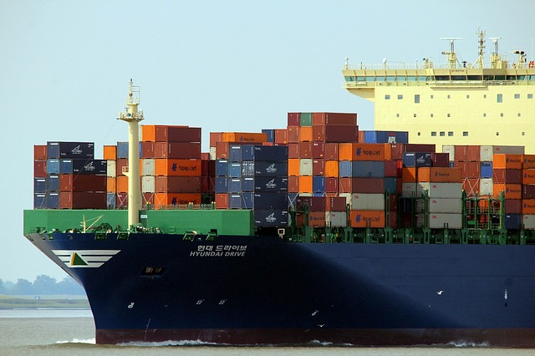
H&M – A women´s clothing store opened in Sweden in 1946. This store was called Hennes, which means “for her” in Swedish. The owner was called Erling Persson. In 1948, Persson bought a hunting and fishing store called Mauritz Widforss. He combined the brands and named the new store Hennes and Mauritz, also known as H&M. The store began to sell women´s, men´s and later also children’s and baby clothes.
You can find H&M stores in over 50 countries in the world and there were more than 4,900 of them in 2021. It comes from Sweden, but most stores are located in the USA. H&M has designers who watch fashion trends and they design and produce new styles. They want to bring new styles into their shops fast and you can see new clothing arrive many times during the year.
On the other hand, they want to reduce waste and want to be environmentally friendly. Starting in 2013, you can bring your clothing from any brand to any H&M store and you can get a coupon for a price reduction.

A lot of labels
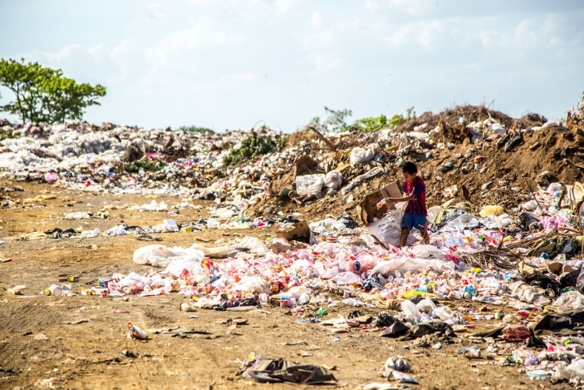
New Yorker – it is one of the largest clothing companies in Europe. Tilmar Hansen and Michael Samson opened the first New Yorker store in the northern German city of Flensburg in 1971. An owner of a jeans store, Friedrich Knapp, started to work with them. New Yorker opened the first branch in Austria in 1994. Four years later you could find New Yorker in Poland, the Czech Republic, later in Hungary, Mallorca and in more and more countries. In 2021, there were over 1,000 stores in almost 40 countries. Its owners say: “We make fashion for real moments.” Their well-known labels are FISHBONE (sport street clothing), AMISU and SMOG (elegant and formal clothing), and CENSORED (a label of underwear and swimsuits). A motto of New Yorker is „Dress for the moment”. Knapp founded a foundation to aid children and helped people after the catastrophes in Haiti or Pakistan.

Cycle life in labels
C&A – The history of C&A begans in 1841. Brothers Clemens and August Brenninkmeyers left their hometown in Germany and moved to Netherlands, where they opened a textile warehouse. The first C&A store opened 20 years later there. It was one of the first outlets to offer „ready-to-wear“ fashion for women. C&A is very popular and there are more than 1,500 stores around the world. In 1957, C&A started to sell menswear. It is the world´s largest buyer of organic cotton. It offers 10 different labels representing the whole cycle of life: you may know labels Palomino, Clockhouse, here & there and others. It also produces latest fashion for babies and children.

Labour for children
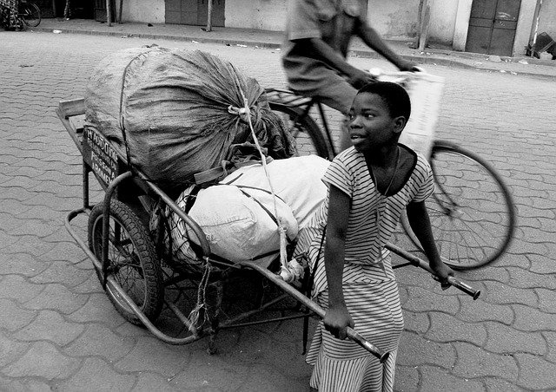
Clothing in the world – Bangladesh is the biggest producer of clothing in the world. However, people make a lot of clothing for little money there. Besides, almost 11% of the world´s children are in child labour. Child labour is a problem not only in Bangladesh, but also in other countries, e.g. in China, India, Egypt, Uzbekistan and Thailand. Local managers may say: „With us, children will get a lot of money, eat three times a day and they will start schooling“ – and parents may believe their situation will be better. Child labour is hard, though. Children as young as 10 years of age work long hours in factories, they cannot go home or to school, they have no time or place to play. Sometimes they even sleep, eat and wash there. Many of them make as little as about 250 Czech crowns per month. Do you know if your favourite fashion stores use child labour?

SQP2RS

Questions | Possible answers | True answers

Zde máš několik námětů, jak si můžeš ověřit to, co ses dozvěděl/a i naučil/a.

- Nakresli obrázky vztahující se k tomu, co jsi četl/a. Kolem obrázků umísti tři až pět vět, využij fakta z textu.
- Použij tato slova v souvislém textu: child labour, store, label, Europe, country.
- Vyber si z textu pět nejdůležitějších slov (jsou důležitá pro tebe) a užij je v textu tak, abys vyjádřil/a, proč jsou pro tebe významná.
- Napiš 3 fakta, která ses z textu dozvěděl/a a která bys řekl/a rodičům, když byste dnes společně večeřeli a oni by se tě zeptali, co ses dnes ve škole dozvěděl/a.
- Vypiš z textu nadpisy a pod každý nakresli obrázek a vyjádři se slovy k obrázku, co na něm je, proč zrovna toto apod.
Příloha | 4.14 Diamant
Tematický blok | 2.3 Tematický blok č. 3 (Móda kolem nás)
Téma | 2.3 Tematický blok č. 3 (Móda kolem nás)

Diamant

______________
_______________ ______________
______________ _______________ _______________
_______________ _______________ ________________ _______________
_______________ _______________ ________________ _______________
______________ _______________ _______________
_______________ ______________
______________

Příloha | 4.15 Tvoříme
Tematický blok | 2.4 Tematický blok č. 4 (Naše tvorba)
Téma | 2.4.1 Téma (Aktivity na téma móda)
Náměty – móda
Práce se slovní zásobou:
- křížovka – obrázek či překlad z anglického jazyka do českého,
- přesmyčky,
- kvarteto na oblečení.
Práce s textem, větami:
- křížovka s definicemi,
- kvíz – otázky a tři možnosti odpovědí,
- hledání informací o návrháři a vytvoření
aktivity – spojování otázky a odpovědi.

Náměty – móda
Práce se slovní zásobou:
- křížovka – obrázek či překlad z anglického jazyka do českého,
- přesmyčky,
- kvarteto na oblečení.
Práce s textem, větami:
- křížovka s definicemi,
- kvíz – otázky a tři možnosti odpovědí,
- hledání informací o návrháři a vytvoření
aktivity – spojování otázky a odpovědi.

Příloha | 4.16 Questions and answers
Tematický blok | 2.5 Tematický blok č. 5 (Sporty)
Téma | 2.5.1 Téma (Adrenalinové sporty)
Questions | Answers
What are your favourite sports?
Why do you like them?
What is your favourite summer sport?
How often do you play/do them?
What sports are you good at?
Who do you play/do sports with?
Do you watch any sports on TV?
What sports do you like to watch live?
Have you ever tried any adrenalin sport?
Which sport would you like to try nowadays or in future?
Is there a sport that you do not like? Which is it?
Příloha | 4.17 Names of adrenaline sports
Tematický blok | 2.5 Tematický blok č. 5 (Sporty)
Téma | 2.5.1 Téma (Adrenalinové sporty)

Find the sports and write them under the table
gliding | Free | Scuba | Snow
climbing | Bungee | climbing | Mountain
jumping | Rock | Hang | Parkour
biking | skiing | diving | climbing
Water | Ice | running | kiting

_______________________________ _______________________________
_______________________________ _______________________________
_______________________________ _______________________________
_______________________________ _______________________________
_______________________________ _______________________________
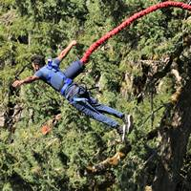
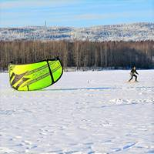
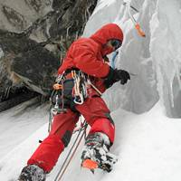
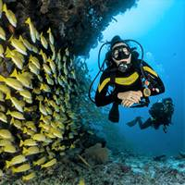
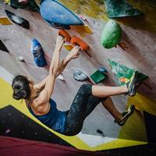
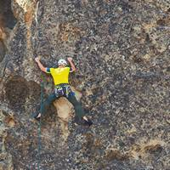
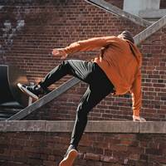
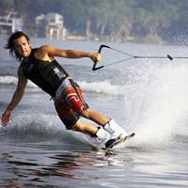
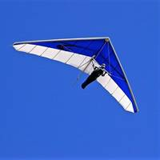
_______________________________ _______________________________

Opinions of my classmates:

Příloha | 4.18 Look for…
Tematický blok | 2.5 Tematický blok č. 5 (Sporty)
Téma | 2.5.1 Téma (Adrenalinové sporty)

Adrenaline sports

I am interested in the following sports and I know enough information about them.

Websites and key words | Information
1st sport
1st sport

My opinion
2nd sport
2nd sport

My opinion
3rd sport
3rd sport

My opinion
4th sport
4th sport

My opinion

Which website helped you and was interesting for your topic? ___________________________

Příloha | 4.19 Sebehodnocení
Tematický blok | 2.5 Tematický blok č. 5 (Sporty)
Téma | 2.5.1 Téma (Adrenalinové sporty)
1. blok: Sporty
Dokážu napsat text v angličtině o nejméně 50 slovech, když reaguji na otázky.
Pojmenuji nejméně 10 adrenalinových sportů, přiřadím je k obrázkům a anglicky vyjádřím vlastní postoj.
Dokážu vyhledat na internetu dle pravidel práce se zdroji potřebné informace.
Rozumím tomu, co mi někdo anglicky sdílí, a dokážu na to reagovat.
Spolupracuji se spolužáky, akceptuji jejich názory a nezlehčuji je.

2. blok: Známé adrenalinové sporty
Rozumím nové slovní zásobě a při práci s textem rozumím textu.
Dokážu sdělit souvisle v angličtině nejméně deset informací na základě textu.
Spolupracuji ve dvojici, snažím se porozumět a reagovat, tvořit požadovanou práci.
Dokážu vyjmenovat nejméně 10 adrenalinových sportů.
Slova týkající se adrenalinových sportů umím použít ve smysluplné anglické větě.

3. blok: Nebezpečí
Znám nejméně osm slovíček, kterým v prezentaci rozumím, a jsem schopný/á je ve svém projevu uplatnit.
Na základě přečteného textu dovedu vytvořit jednoduchou prezentaci, kterou dovedu srozumitelně předat spolužákům.
Zaujímám vlastní postoj k adrenalinovým sportům, umím ho obhájit, uvést výhody a nevýhody těchto sportů.
Dokážu zformulovat své myšlenky a napsat souvislý vzkaz sportovci.
Ve dvojici jsem pracoval/a zodpovědně a byl/a jsem schopen/schopna přijmout i jiné nápady, názory.
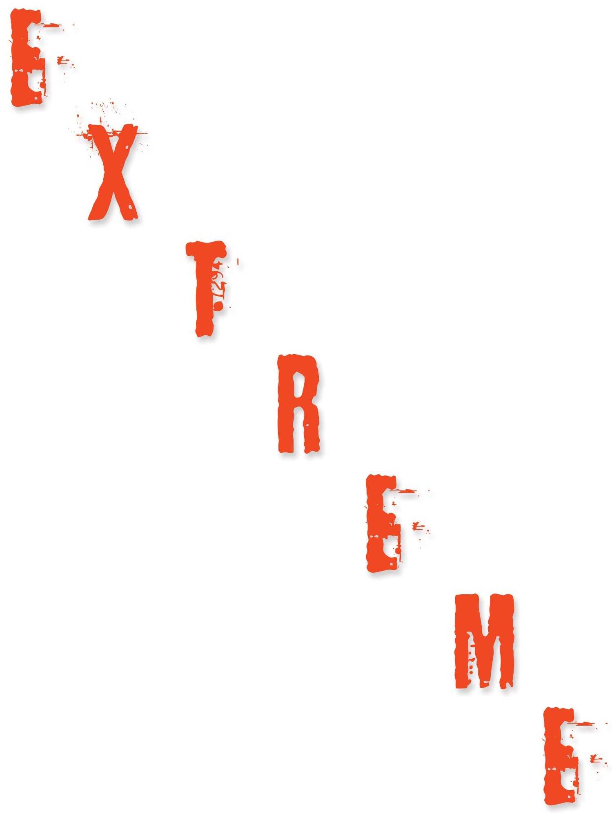
4. blok: Sebehodnocení
Práce ve dvojici při tvorbě materiálů mě _______________
Používal/a jsem angličtinu co nejvíce v rámci svých schopností.
Jak bys ohodnotil/a míru získaných poznatků?
__________________
Pracovní listy spolužáků či jiné aktivity bych ocenil/a ____________
Z čeho jsi měl/a největší radost u tématu adrenalinových sportů?
Co bys příště udělal/a jinak?
Čím jsem byl/a nejvíc užitečný/á při spolupráci se spolužáky?
Příloha | 4.20 Three items together
Tematický blok | 2.6 Tematický blok č. 6 (Známé adrenalinové sporty)
Téma | 2.6.1 Téma (Co mají společného, čím se liší)
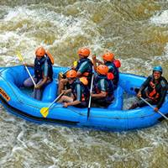
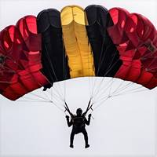
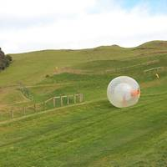

hang gliding | The activity of flying through the air by hanging from a very small aircraft without an engine.
bungee jumping | The sport of jumping off a very high bridge or similar structure, with a long elastic rope tied to your body, so that the rope pulls you back before you hit the ground.
rock climbing | The sport of climbing on rocks or in mountains.
water skiing | The sport when you are pulled on water surface by a boat, while you are on a pair of skis.
parkour running | An activity in which people move quickly around buildings and objects in a city while performing jumps and others tricks.
ice climbing | It is a lot like a rock climbing, but you climb on icefalls (frozen waterfalls).
zorbing | An activity in which someone rolls down a hill or along the surface of water in a large plastic ball.
skydiving | A sport in which a person jumps from a plane and falls for as long as possible before opening a parachute.
rafting | A sport in which you use a rubber raft to travel along with the current (proud) of a river.
snow kiting | Skiing or snowboarding with a kite that helps you glide on snow or ice.

Příloha | 4.21 Stepping stones
Tematický blok | 2.6 Tematický blok č. 6 (Známé adrenalinové sporty)
Téma | 2.6.1 Téma (Co mají společného, čím se liší)

somersault  /ˈsʌməsɔːlt/ | salto | movement  /ˈmuːvmənt/ | pohyb
trick  /trɪk/ | trik | improve  /ɪmˈpruːv/ | zlepšit
trust  /trʌst/ | důvěřovat, důvěra | freedom  /ˈfriːdəm/ | svoboda
fear  /fɪə(r)/ | strach | overcome  /ˌəʊvəˈkʌm/ | překonat
stuntman  /ˈstʌntmæn/ | kaskadér | obstacle  /ˈɒbstəkl/ | překážka
grace  /ɡreɪs/ | ladnost

Příloha | 4.22 Kvíz
Tematický blok | 2.6 Tematický blok č. 6 (Známé adrenalinové sporty)
Téma | 2.6.1 Téma (Co mají společného, čím se liší)

Quiz

When did parkour become a sport?
- 1950s
- 1990s
- 2000s

In parkour they don´t:
- dance
- run
- move

Where did people start with parkour?
- France
- Italy
- England

Parkour is about:
- moving your legs
- moving your body
- moving your arms and legs

Do you need any special clothes or equipment
for doing parkour?
- yes
- no

Where can you practise parkour?
- everywhere
- in the gym
- in the playground

Is freerunning older than parkour?
- yes
- no

What do freerunners also often do?
- gymnastics
- box
- aerobic

Where does freerunning come from?
- France
- Italy
- England

What is freerunning about?
- freedom of words
- freedom of movement
- freedom of running

What is Jump London?
- the most famous book about freerunning
- a documentary
- an action movie with freerunners
Příloha | 4.23 Parkour and freerunning
Tematický blok | 2.6 Tematický blok č. 6 (Známé adrenalinové sporty)
Téma | 2.6.1 Téma (Co mají společného, čím se liší)

Parkour

Parkour comes from France. The roots of parkour are in the army. Soldiers were trained to move across natural obstacles efficiently. David Belle transformed this method into parkour in 1990s. His father inspired him and told him to follow his dreams. His group, founded in 1998, was called Yamakasi (the word means strong man, strong spirit) and its members trained jumps, climbs, rolls and vaults in the streets of a city. David became famous, he was an actor and a stuntman. According to Belle, parkour can be called an art, not only a sport.

Parkour is an excellent exercise because it helps you to keep healthy and fit. A man who practises parkour is called traceur, a woman is called traceuse.

Parkour is about moving of your body from place to place and past obstacles safely and as quickly as possible. People can use running and jumping. It is not a competition. The most important thing is to improve your physical skills, to overcome limits, to overcome fear. It is a way how to become more confident and fearless. Parkour teaches people how to trust themselves, to learn to be careful. For doing parkour you do not need expensive equipment, only your own clothes and shoes. You can practise everywhere, because walls, benches, fences and stairs are in all towns and villages. You can even see people who practise parkour in their office, over bins and desks. Belle´s opinion is that we should train real parkour outside. You must always remember it can be a dangerous sport, though. You need to know and understand the different basic moves. Parkour is an individual discipline.

Safety is very important here. The best thing how to improve your skill is to join a group and train together.

David Belle was born in 1973 and tried several jobs. He was a firefighter, then worked in the army. He began his acting career in a show in 1997. He is an actor and he is famous because of the movie District 13 (2004, 2009). He showed parkour there and became famous. Parkour is in many movies nowadays.

People who practise parkour use different tricks and moves, e.g. landing, the Lazy Vault, Side Vault, Kong Vault and others. Parkour is not about freedom of movement, it is not acrobatics and somersaults, it is not about jumps from the highest points.

Freerunning

Freerunning is similar to parkour, but people run up walls and jump from roof to roof. Freerunning was founded in 2003. Freerunners are good at tricks (acrobatic movements). They can also use dance and gymnastics. It is not about fast movements, but about tricks. Sebastien Foucan, the founder of freerunning, was a friend of David Belle. Sebastien was born in 1974 and lived in France, nowadays he lives in London where he develops freerunning in Foucan Freerunning Academy. He was inspired by parkour. Sebastien played in the movie Casino Royale, where he appeared in the opening chase scene with Daniel Craig.

Sebastien did not see as important only the speed, but also freedom and grace. Everybody is free and can choose his or her own way. Freerunning borrows efficient movements from parkour, but changes some rules. It meant a way from parkour to somersaults (salta) and handsprings (přemety). The term freerunning was invented during the filming of Jump London. Freerunning became more famous than parkour in the Czech Republic, but people do not know it is freerunning what they watch.

Both, parkour and free running, look very similar. Freerunning is a social sport of physical expression. People who practise free running are called freerunners. This sport is not easy and freerunners have sometimes accidents. Freerunners prefer to train in a gym, not in real places, because during practising some tricks freerunners can get injured quite easily.

Famous people use freerunning in their music videos, because it is exciting to watch.

Překážky ve freerunningu je možné zdolávat různými technikami, jako jsou flipy, různá salta, ale také triky s názvy jako vault, kabolo, corkscrew, stunty, wushu a další.

Jde o vytvoření atraktivního způsobu pohybu. Freerunning dává prostor pro vlastní tvořivost, výběr cesty a způsoby provedení. Freerunning si získal mnoho lidí kvůli své myšlence svobody a volnosti, ale zároveň i uchování krásy pohybu.

Příloha | 4.24 Vennův diagram
Tematický blok | 2.6 Tematický blok č. 6 (Známé adrenalinové sporty)
Téma | 2.6.1 Téma (Co mají společného, čím se liší)

Příloha | 4.25 Fakt extrémní
Tematický blok | 2.7 Tematický blok č. 7 (To be scared)
Téma | 2.7.1 Téma (Dangerous sports)

Text 1

Volcano surfing
It is an adrenaline sport you can practise on volcano slopes. In Nicaragua, there are some very popular slopes on 19 volcanoes. Riders go up the volcano, sit or stand on a metal board and slide down. It is dangerous, because you can fall off and get cut by the volcanic ash (prach), or you can be hit by lava. There are also gasses which are not OK for your lungs and breathing. Riders wear goggles (brýle) and jumpsuits and also use cheap shoes because volcano is usually hot and the shoes can get melted. This sport was founded in 2002 by Zoltan Istvan who made a video of his slide down a volcano. The most popular volcano in Nicaragua is the one called Cerro Negro. The slope is very steep (41 degrees) and the riders can get a speed over 50 mph. Riders must walk up because there is no other means of transport.

Text 2

Highlining
It is a sport where a person walks on a slackline high above the ground. Highlining is practised in heights between mountains, buildings or bridges and the heights are greater than 20 meters. The person who walks the line wears a harness attached to the main line, which can save his life. When the line is in the heights from 10 to 20 metres, it is called midline. Some people risk a lot and there can happen accidents. For highlining you need a slackline with anchors (jištění) and wear a harness attached to the slackline, but long trousers, gloves, clothes with long sleeves and good shoes can also be useful. You should not carry sharp objects or wear any jewellery. Dean Potter from the USA became famous for his dangerous “free-solo” (with no harness) crossing in the Yosemites. He was interested in base jumping too and he died when he practised it.

Text 3

Base Jumping
It is one of the most dangerous extreme sports. It is a sport in which a person jumps from a fixed object and uses a parachute. The parachute should slow the person down shortly before he or she would hit the ground. There are four types of objects that athletes jump of: buildings, antennas, bridges, and cliffs. This sport is about speed, danger, height, and stunts. This sport comes from skydiving but base jumping is much more dangerous. Skydivers have 3 minutes after opening their parachutes to reach the ground, but base jumpers have only several seconds. The record of the lowest base jump was a jump from 33,5 metres. It is an extremely risky sport: in each sixty jumpers, one person dies. The first jump was filmed in 1978 and it meant the beginning of base jumping. Who wants to practise base jumping needs a safety helmet, knee pads, trekking boots and a parachute (jumping equipment).

Text 4

Bungee jumping
It is a sport in which you jump from a great height. The person is tied to a long elastic rope. The rope is attached to the body and to the jump platform. When the jumper jumps, the rope stretches (natáhnout se) and the jumper bounces (odrazit se) back up. The jumper needs a helmet and a harness. People usually bungee jump from mountains, bridges or buildings – it means from fixed places. There were also jumpers who jumped from a plane, though. The jump can be done in many styles and techniques.
Bungee jumping was founded in Great Britain in 1979. The first bungee jump for public (veřejnost) took place in New Zealand in 1988 and was 47 metres long. The world’s highest jump was in China from the height of 233 metres. The oldest person who tried it was 96 years old. Bungee jumping is also a dangerous sport, it can for example damage your eyesight.

Text 5

Ice climbing
It is a sport in which people climb frozen waterfalls or large rocks covered with ice. It is more difficult than rock climbing. Climbers use 2 axes, ropes, harness, crampons (mačky), carabiners, an ice screws which they put into ice to create anchors (jisticí body). They also need gloves and a climbing helmet. When climbers go up, they use the axes to hold on ice above their heads. Unexperienced climbers should have a guide to go ice climbing. Climbers are in danger when they climb because they can fall down, and falling rocks or ice can hit them. This sport is old: in 1908 a climber named Oscar Eckenstein designed crampons. There are a lot of places where you can go ice climbing – there are even several such places in the Czech Republic, for example in Jizerské hory.

Text 6

Scuba diving
It is an underwater sport. Divers use an underwater breathing (dýchací) apparatus. Jacques Cousteau invented scuba gear in 1943. Recreational scuba divers dive only 40 metres, but the record is 332 metres. Ahmed Gabr, who made this record, reached this depth in 12 minutes, but he was getting up for about 15 hours. Divers must get back slowly because of health risks. The longest stay underwater was in 2003, the man was there for 49 hours and 56 minutes. Scuba diving is a sport in which the body burns a lot of calories, because it must warm itself. There are about 6 million scuba divers in the world. Scuba divers need a diving mask, fins, a wetsuit, scuba gloves, a scuba tank, and a dive computer. Scuba diving is not dangerous when divers follow all rules, have the right gear and obey the instructions of their guides. You can try scuba diving in our country in some swimming pools.

Text 7

Creeking
It is a sport which is similar to canoeing or kayaking. In fact, it means kayaking in difficult white water (divoká voda). People paddle in very narrow rivers (creeks) to go down waterfalls and other steep and fast parts of the river. The equipment includes elbow pads, float bags, a helmet, first aid kit, paddles, a special whitewater kayak that is about 1.8 metres long, masks, a wetsuit and a life vest. Creeking is more dangerous than other types of kayaking, because it needs extra gear. Whitewater kayakers need specific water flows (proud) to do this sport. It is a dangerous sport because they can hit a rock, get caught between them, the canoe can break, or they can get under water and die. If you want to try creeking, you can visit Little White Salmon river in the USA or go to creeks in Canada, Mexico, Spain, or New Zealand.

Text 8

Heliskiing
This sport was founded in the 1960s in Canada. Nowadays, there are many places for heliskiing, but the best can be found in Alaska, Canada, Japan, and Switzerland. The skiers get to the mountains by helicopter that lands on snow, the skiers step out and put on their skis or snowboards. They need also a helmet, gloves, goggles, waterproof and warm clothes, and ABS airbags. The skiers must be excellent at skiing and be healthy, as the ride can be quite long and exhausting. They ski down in a cloud of snow, in areas and on slopes of virgin powder snow (neporušený prašan). Heliskiing brings freedom and joy from natural environment. It is an extreme sport, but when skiers respect experienced guides, the danger is not that high. Skiers must also check the weather forecast every day and watch for avalanches. If somebody wants to try a really extreme heliskiing, he or she can try skiing in India and see the Himalayas, or go to Russian Kamchatka with its 200 snow-covered volcanoes.

Příloha | 4.26 Co já?
Tematický blok | 2.7 Tematický blok č. 7 (To be scared)
Téma | 2.7.1 Téma (Dangerous sports)
Name of the sport | What I have learned about it: | Name of the sports I like or want to try (3) and also sport I DON’T like or want to try (1)

Příloha | 4.27 Vzkaz sportovci
Tematický blok | 2.7 Tematický blok č. 7 (To be scared)
Téma | 2.7.1 Téma (Dangerous sports)
Dear
I´m and I´m from I´m into
I read/heard
I was surprised that you
I admire
I didn´t expect that
You must be
I have never
In my opinion
I wish you
Best regards

S pozdravem
Příloha | 4.28 Tvoření
Tematický blok | 2.8 Tematický blok č. 8 (Tvorba materiálů)
Téma | 2.8.1 Téma (Naše nápady)
Práce se slovní zásobou:
• křížovka – obrázek či překlad z anglického jazyka do českého,
• přesmyčky,
• kvarteto na adrenalinové sporty.
Práce s textem, větami:
• křížovka s definicemi,
• kvíz – otázky a tři možnosti odpovědí.

Náměty – adrenalinové sporty

Práce se slovní zásobou:
• křížovka – obrázek či překlad z anglického jazyka do českého,
• přesmyčky,
• kvarteto na adrenalinové sporty.
Práce s textem, větami:
• křížovka s definicemi,
• kvíz – otázky a tři možnosti odpovědí.
Náměty – adrenalinové sporty

Příloha | 4.29 Výstupní kompetenční dotazník

Výstupní kompetenční dotazník
Trochu jiná angličtina 2
Nyní tě poprosíme o vyplnění závěrečného dotazníku. Jedná se téměř o stejný dotazník, který jsi vyplňoval/a před začátkem programu. Cílem dotazníku je zjistit, jestli ti program přinesl něco nového, jestli tě bavil a jestli ses něco nového naučil/a. Opět se nejedná o test, takže tě nikdo známkovat nebude.
Nakonec můžeš porovnat své odpovědi s dotazníkem na začátku a zjistit, kde ses nejvíce posunul/a.
Otázky pro výstupní dotazník:
- V angličtině vyjmenuj 5 různých termínů spojených s tématem módy a 5 druhů adrenalinových sportů.
Móda: Sport:
______________________ _______________________
______________________ _______________________
______________________ _______________________
______________________ _______________________
______________________ _______________________

- Daří se ti využívat angličtiny v konverzaci o jednotlivých tématech či prezentacích?
- ano
- ne

- Daří se ti analyzovat a srovnávat klíčové informace v předložených textech?
- ano
- ne

- Daří se ti vyhledávat informace na internetu z různých zdrojů a vytvořit na počítači zábavné úkoly pro tvé spolužáky?
- ano
- ne

- Daří se ti respektovat spolužáky, hledat řešení při práci ve skupině a přistupovat k ní zodpovědně?
- ano
- ne

