CRUZ ORACULAR

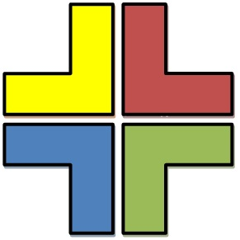

PENTAGRAMA

Filosofía:
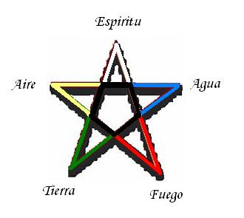
Colors

Colors

Colors

Colors

Colors

Colors

Colors

Colors

Pentagono

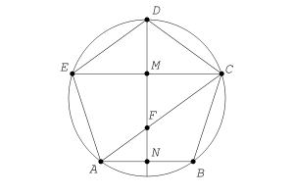

CRUZ ORACULAR

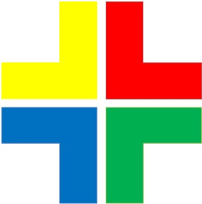

PENTAGRAMA

