 | CRUZ ORACULAR

 | CRUZ ORACULAR

 | CRUZ ORACULAR

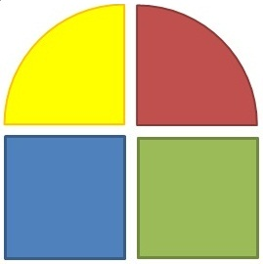 | ENERGYM

 |   C  R  U  Z  O  R  A  C  U  L  A  R

