Date | Ver | Author | Approve | Description
2021/08/24 | v1.01 | QZS | ZY，CSL,YT | Page8 step5添加使用highpoint产品前需清除磁盘的提示。
2021/12/1 | V1.02 | ZY | CSL,YT | 添加数据线8654-8611和8654-8643的介绍；  修改8654-8639数据线名称错误  Sunlin – 更新插入主板图；更新链接


SSD7580A
PCIe Gen4 x16 8-Port U.2 NVMe RAID Controller
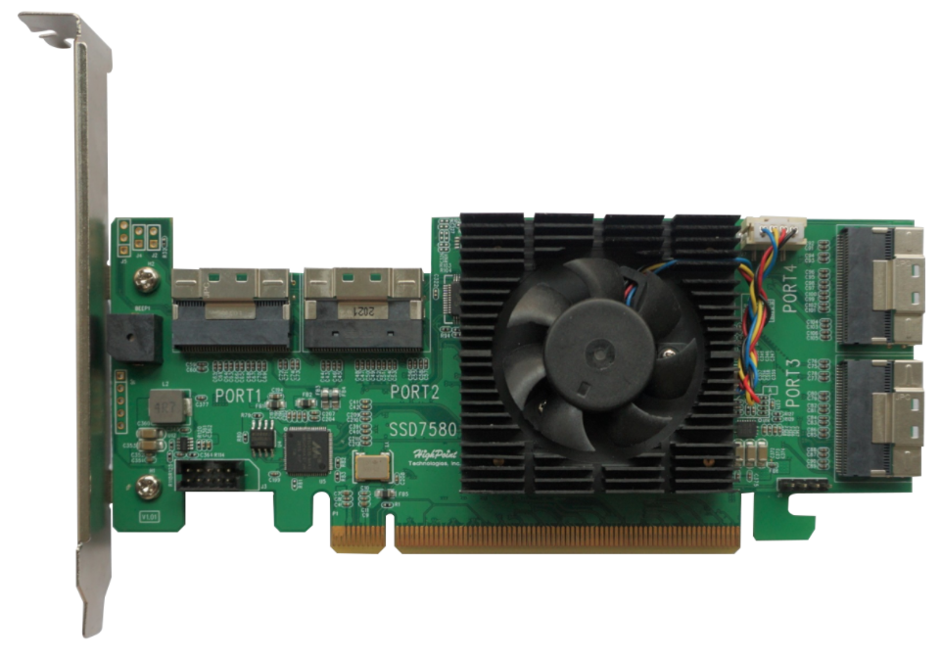

Quick Installation Guide
V1.02

System Requirements
PC Requirements
- System with a free PCIe4.0 (or 3.0) x16 slot
- Windows 10/11, Windows Server 2016/2019/2022 and later.
- Linux kernel 3.10 and later

SSD7580A Kit Content
- SSD7580A Controller Card
- Quick Installation Guide

SSD7580A Hardware
Front View
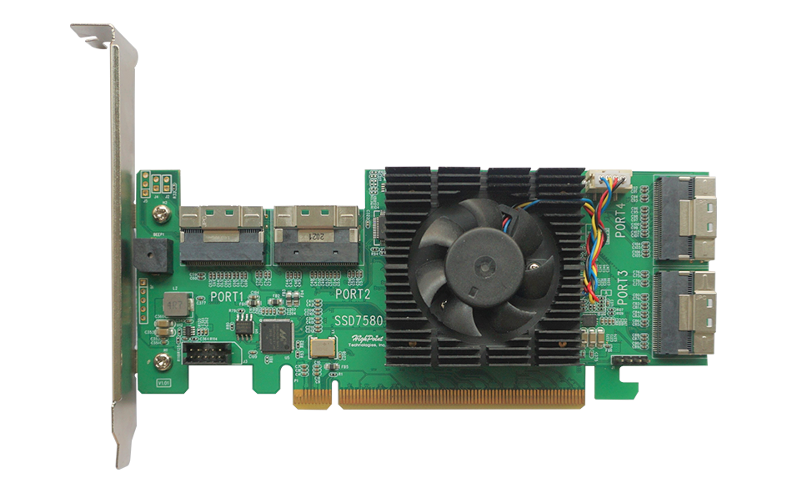

Hardware Installation:
- The SSD7580A provides 4 SFF-8654 to U.2 SFF-8639 connectors on the right side and top of the controller PCB. Each of these ports was designed for use with HighPoint TS8i-8639-060 NVMe cables that have 15-pin SATA power connectors.
SFF-8654 ports
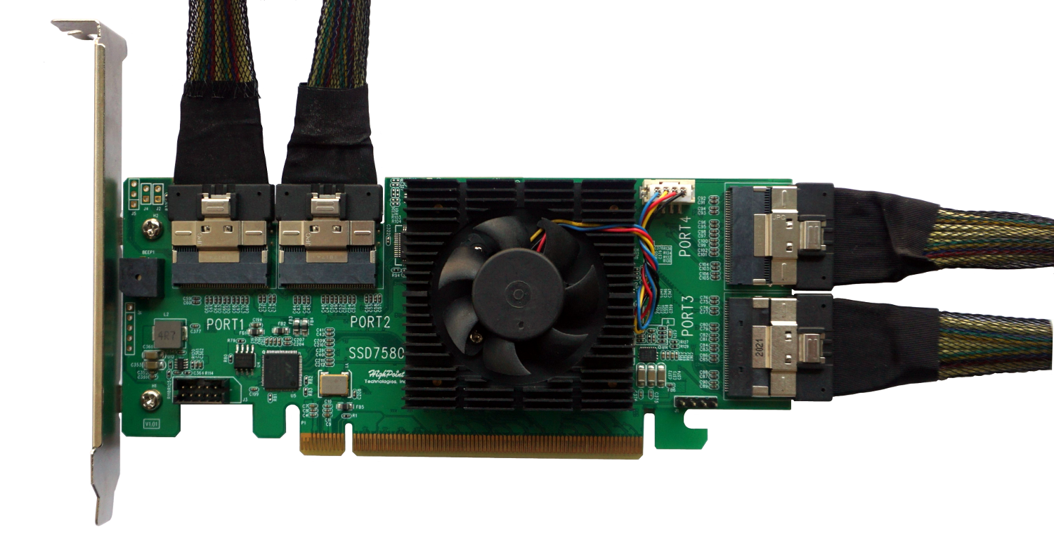
SFF-8639
SATA-15pin
SFF-8654

TS8i-8639-060
NVMe cable
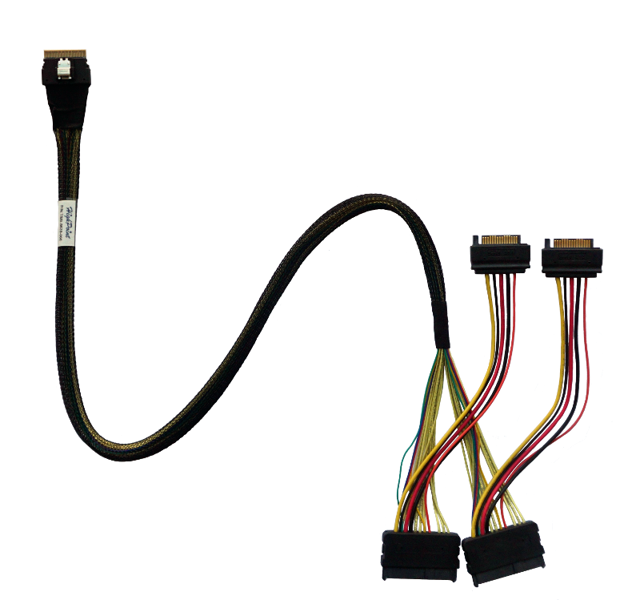

- Shown above is a SFF-8654 to U.2 SFF-8639 cable with a 15-pin SATA power connector. The SFF-8639 port should be connected to the NVMe SSD’s U.2 port. The 15 pin SATA power connector should be connected to the system’s power supply.

- Insert the SSD7580A controller into one of the motherboard’s open PCI-E 4.0x16 slots.
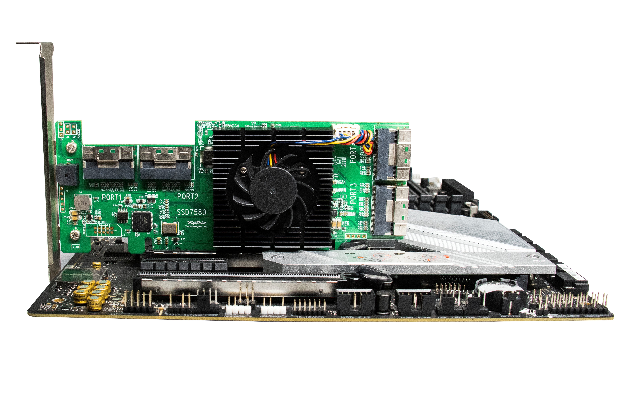

- Connect two pieces of NVMe with SFF-8639 port, and connect SFF-8654 port to SSD7580A. Connect the 15-pin SATA power connector to the system's power supply.
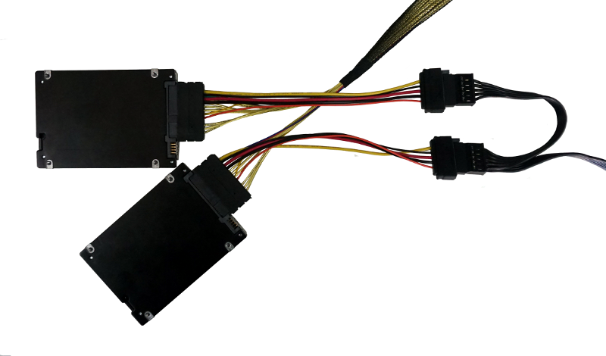
15-pin SATA power connector
SFF-8639
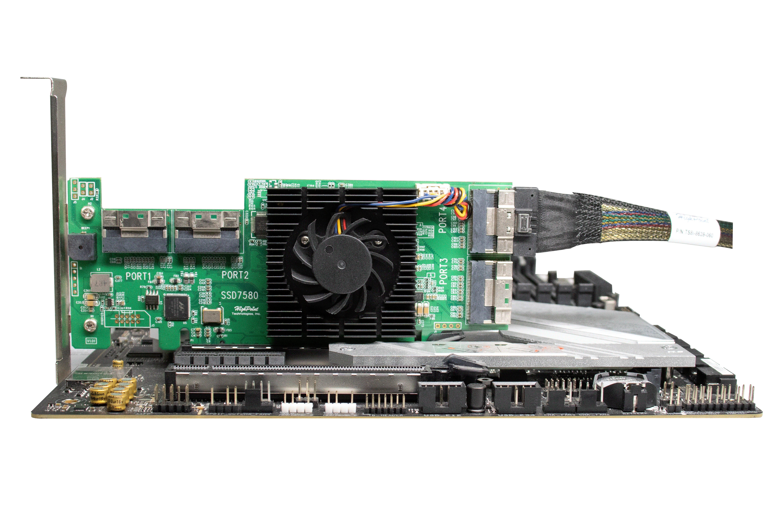
- Connect the remaining NVMe SSDs to the SSD7580A controller as described above. Once complete, Power on the system
Note: Please make sure all disks are clean before you connect them to the controller to avoid unexpected situations.
Note: Make sure SSDs are connected to the SSD7580A before powering on the system

Optional Certified Cable Accessories
SSD7580A (External)
8654-8643-210  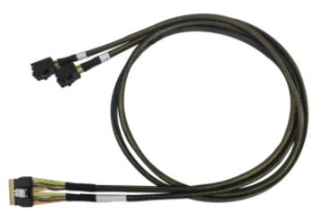 | SFF-8654 to SFF-8643 NVMe cable, 1meter length  The 8654-8643-210 is external SFF-8654 (host) to SFF-8643 (device) PCIe 4.0 x8 NVMe cable, and each cable can host up to 2x NVMe SSDs.
8654-8611-205  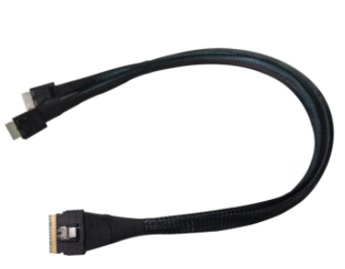 | SFF-8654 to SFF-8611 NVMe cable, 0.5meter length  The 8654-8611-205 is external SFF-8654 (host) to SFF-8611 (device) PCIe 4.0 x8 NVMe cable, and each cable can host up to 2x NVMe SSDs via an SFF-8611 Oculink connection.

Resources
A variety of manuals, guides and FAQ’s are available for the SSD7580A RAID controller.
In addition, we recommend visiting the Software Downloads webpage for the latest drivers, management interfaces, and installation guides.

Software Download:
SSD7580A Driver, WebGUI, Installation Guides:
https://www.highpoint-tech.com/ssd7500-series-overview
Other Reference Information:
Motherboard & NVMe SSD Compatibility List
SSD7580A User Guides
https://www.highpoint-tech.com/ssd7500-series-overview

Customer Support
If you encounter any problems while utilizing the SSD7580A, or have any questions about this or any other HighPoint Technologies, Inc. product, feel free to contact our Customer Support Department.
Web Support:
https://www.highpoint-tech.com/websupport
HighPoint Technologies, Inc. websites:

https://www.highpoint-tech.com

© Copyright 2021 HighPoint Technologies, Inc. All rights reserved.

